**IBM - Nallaiya Thiran Project**

**Assignment 1**

**Smart Home**

**NIRANJAAN VM**

**2019503536**

**Circuit Diagram:**

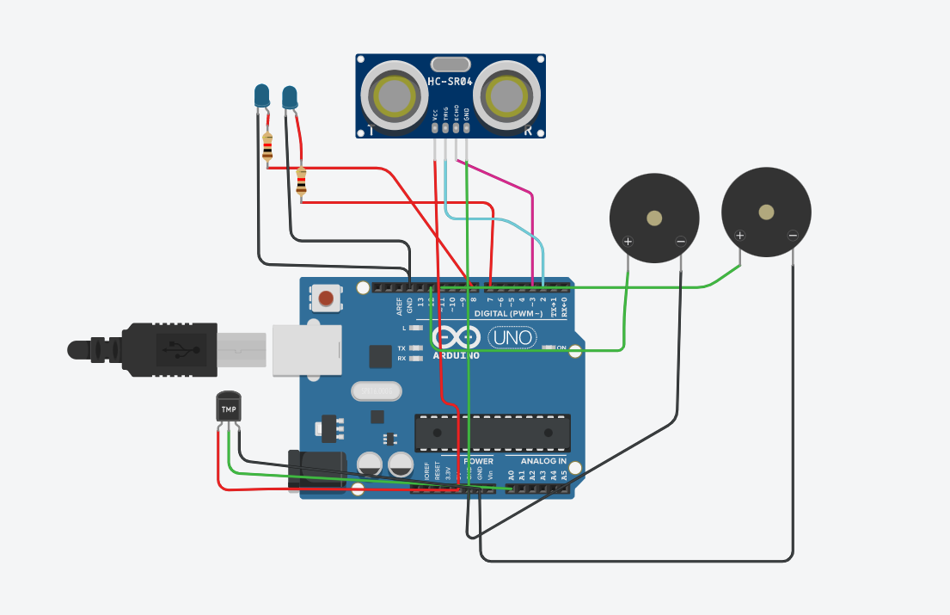

**Source Code :**

int t=2;

int e=3;

void setup()

{

Serial.begin(9600);

pinMode(t,OUTPUT);

pinMode(e,INPUT);

pinMode(12,OUTPUT);

}

void loop()

{

//ultrasonic sensor

digitalWrite(t,LOW);

digitalWrite(t,HIGH);

delayMicroseconds(10);

digitalWrite(t,LOW);

float dur=pulseIn(e,HIGH);

float dis=(dur*0.0343)/2;

Serial.print("Distance is: ");

Serial.println(dis);

//LED ON

if(dis>=60)//(in terms of centimeter)

{

digitalWrite(8,HIGH);

digitalWrite(7,HIGH);

}

//Buzzer For ultrasonic Sensor

if(dis>=60)

{

for(int i=0; i<=5; i=i+1)

{

tone(12,i);

delay(1000);

noTone(12);

delay(1000);

}

}

//Temperate Sensor

double a= analogRead(A0);

double t=(((a/1024)*5)-0.5)*100;

Serial.print("Temp Value: ");

Serial.println(t);

delay(1000);

//LED ON

if(t>=20)//(in terms of celsius)

{

digitalWrite(8,HIGH);

digitalWrite(7,HIGH);

}

//Buzzer for Temperature Sensor

if(t>=20)

{

for(int i=0; i<=5; i=i+1)

{

tone(12,i);

delay(1000);

noTone(12);

delay(1000);

}

}

//LED OFF

if(t<20)

{

digitalWrite(8,LOW);

digitalWrite(7,LOW);

}

}

**Output:**

* **Serial Monitor:**

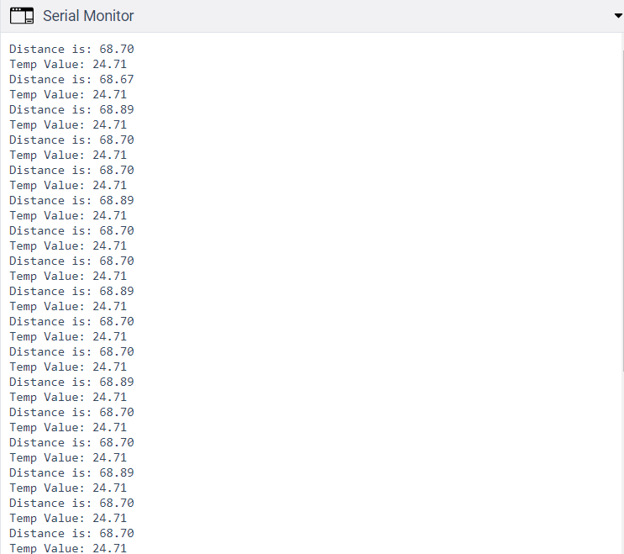

* **Circuit Diagram:**

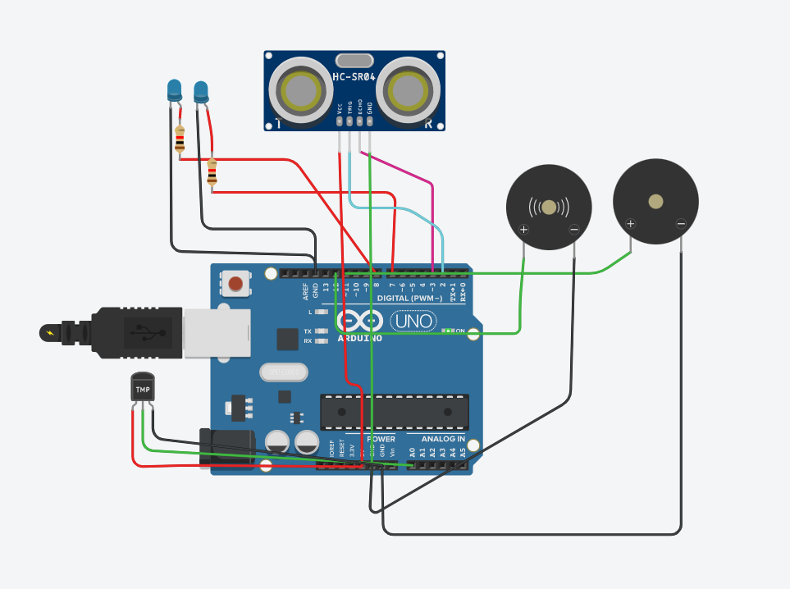

**Tinkercad Link:**

[**https://www.tinkercad.com/things/1ghj2kf5kjS-spectacular-esboo-blorr/editel?sharecode=hfdZffmExsOq-3fs1hZDLuc_S6gdbPaaovbpFl8ZLtA**](https://www.tinkercad.com/things/1ghj2kf5kjS-spectacular-esboo-blorr/editel?sharecode=hfdZffmExsOq-3fs1hZDLuc_S6gdbPaaovbpFl8ZLtA)